# **Return Differences between Trading and Non-trading Hours:**

# **Night and Day**

## **Overview**

In a previous study, by several quant researchers it was found that the returns across various asset classes during the night are strongly positive and returns during the day are close to zero and sometimes negative. This day and night effect holds for individual stocks, equity indexes, and futures contracts on equity indexes and is robust across the NYSE and Nasdaq exchanges. Night returns are consistently higher than day returns across days of the week, days of the month, and months of the year. The effect is driven in part by high opening prices which subsequently decline in the first hour of trading.

A reference to the above premise can be found at <http://ssrn.com/abstract=1004081>

There is enough evidence that the above theory works because the opening and closing of markets influence short-term price movements, trading volume, and volatility. The Day and Night Strategy is based on the theory that major movements in stock prices happen overnight as compared to during trading hours. Some degree of positive overnight returns can be expected due to an illiquidity premium as suggested in the model developed by Longstaff (1995).

## **Strategies**

In this article, we will explore the returns delivered by Amazon and Apple Inc while following the Night and Day Trading strategy and show you the Python implementation of the same.

The nightly returns are defined as Buy the stock @ today’s Close and sell @ next day’s Open.

The Day returns are defined as the returns incurred between Buy @ Market Open and Sell @ Market Close.

Also, we will check third strategy just to compare with the above two, which is based on a trading based on Gap-Open. In a Gap-Open trade, we go long when today’s Open is above than Previous Close and exit on Day’s close. Also, we go short when today’s Open is below the Previous Close and exit the trade at the end of the day.

Finally, we will also calculate the returns for a Buy and Hold strategy during the selected period.

## **Python Implementation**

The following are the steps involved in executing the above discussed strategies:

**Step 1**: First we will import the necessary modules for this code.

The modules used are:

Pandas: for creating data frames

Yfinance: for accessing stock data

Datetime: for accessing date and time

matplotlib.pyplot: for plotting graphs

To install these modules on your system use the pip installer.

Now import the modules as shown below:

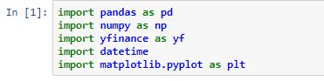

**Step 2**: Enter the Start date and End date between which the returns are generated. Here we will test the returns during the last 5 years time period.

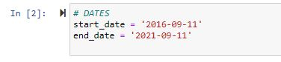

**Step 3**: Let’s download the stock data of Amazon and AAPL between the entered dates. To download data we use:

yf.download(ticker, start_date, end_date)

where ticker is the symbol of stock for Amazon it is AMZN and for Apple it is AAPL.

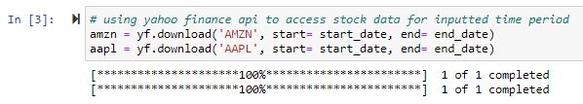

**Step 4**: Cleaning the data. For this strategy, we only require the open and close price of the stocks. So we will remove all the other columns.

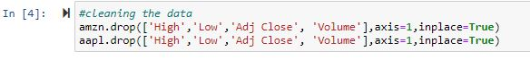

**Step 5**: Now we will calculate the overnight % return for each day. The logic for calculating overnight return is to subtract the closing price of the previous day with the open price of the day and divided by the closing price of the previous day. It goes as below :

(Open — Prev. Close)/Prev.Close

We will also calculate the day return for each day. The logic for calculating day return is to subtract the Close price of the day with the Open price of that dayand divided by the Open price of the day. It goes as below:

(Open – Close)/Open

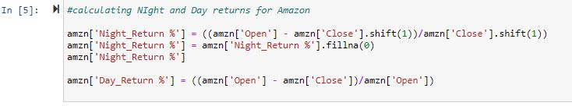

### **Count of Positive and Negative returns for Amazon**

**Step 6**: In this step **let us calculate the number of times the Nightly return strategy and the Day strategy has yielded the Positive and negative returns.**

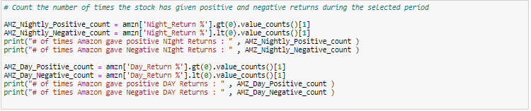

# of times Amazon gave positive Night Returns: 774

# of times Amazon gave Negative Night Returns: 475

# of times Amazon gave positive DAY Returns: 634

# of times Amazon gave Negative DAY Returns: 624

Amazon has given positive returns a greater number of times for the Night strategy than the negative returns, while for the Day strategy the positive and negative count is almost even.

### **Count of Positive and Negative returns for Apple**

# of times Apple gave positive Night Returns: 701

# of times Apple gave Negative Night Returns: 547

# of times Apple gave positive DAY Returns: 583

# of times Apple gave Negative DAY Returns: 673

Apple has given positive returns a greater number of times for the Night strategy than the negative returns, while for the Day strategy the negative returns count is greater than the positive returns count.

**Step 7**: In this step **let us calculate the compounded returns of the Nightly Returns and Day Returns for the selected time period and compare the returns. The cumprod function can be used to calculate the** cumulative product over a DataFrame or Series axis. **The below code is applicable for the Amazon stock.**

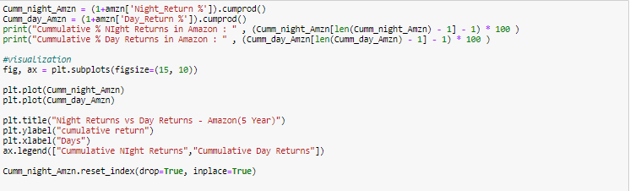

### **Cumulative % Nightly vs % Day for Amazon**

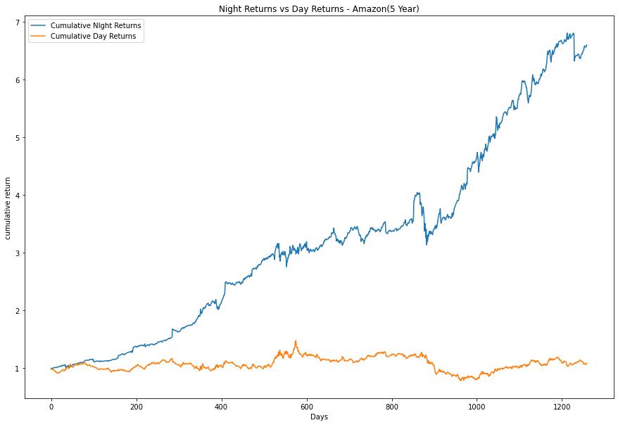

**As can be seen above, both the day and night strategies gave positive returns.**

**However, the cumulative returns for the overnight buy and hold strategy for Amazon in**

**Thelast 5 years has outperformed the Intraday Buy strategy by over 5 times.**

Cumulative % Night Returns in Amazon:659.68

Cumulative % Day Returns in Amazon:108.91

### **Cumulative % Nightly vs % Day for Apple**

**Let us examine how these strategies fared on the Apple stock during the same period.**

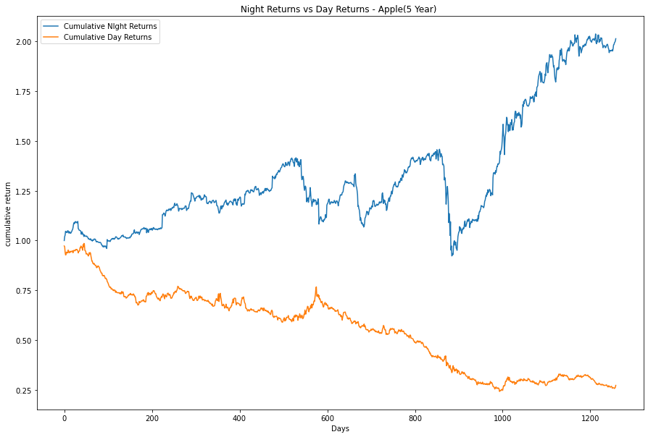

Cumulative % Night Returns in Apple : 201.18452167840655

Cumulative % Day Returns in Apple : 27.59474629563904

The Day trading strategy as can been seen in the plot has completely underperformed the Nightly returns and turned out to be an extreme negative.

When compared to the Apple stock, the cumulative nightly returns of the Amazon stock has outperformed. An initial investment of $100 in Apple has doubled in 5 years while Amazon has given far better returns. An initial investment of $100 in Amazon has increased by 6.5 times.

**Step 8**: In this step and the following, we will code the third strategy which is called the Gap-Open strategy in which we would need to code the positions we would open by following our strategy. Because we are only looking at the past, we can easily do so in Pandas with simple data wrangling. We encode a long position using 1 and a short one with -1. This will simplify calculating the strategy’s returns.

We drop the NaNs, which can be introduced because:

* there is no previous price, which is the case for the first observation
* the previous day’s close is equal to the current day’s open. For this dataset, it did happen a few times.

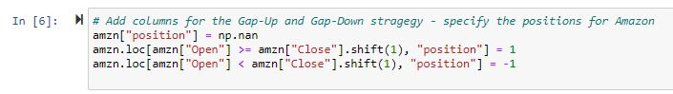

**Step 7**: We have the positions, now we need to see how much we would profit by following the Gap-Open strategy. To do so, we calculate the intraday returns by looking at the difference between the open and close prices. Then, we multiply the returns by the position. Lastly, we calculate the cumulative returns.

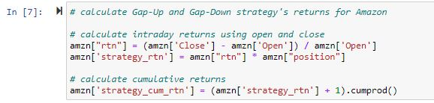

**Step 8**: let’s also have a look at the simple **buy-and-hold strategy**. We buy the asset on the first day (for the closing price) and hold it until the end of the period of interest.



**Step 9:In this step, let us compare the compounded returns of all the strategies (Nightly Returns, Day Returns and Gap-open returns) discussed above for Amazon.** Also, let us print the % returns for all the strategies coded above.

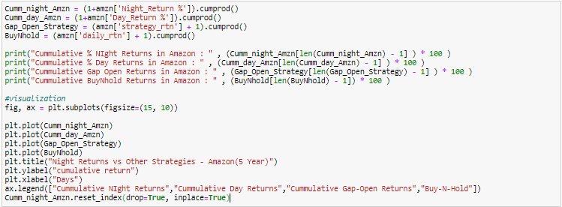

### **Comparison of all four strategies for Amazon 5-year period**

Cumulative % Night Returns in Amazon: 659.68

Cumulative % Day Returns in Amazon: 108.91

Cumulative Gap Open Returns in Amazon: 50.71

Cumulative BuyNhold Returns in Amazon: 449.66

The above returns indicate that for Amazon, the Cumulative Night returns has outperformed all the other strategies including the Buy-N-Hold strategy.

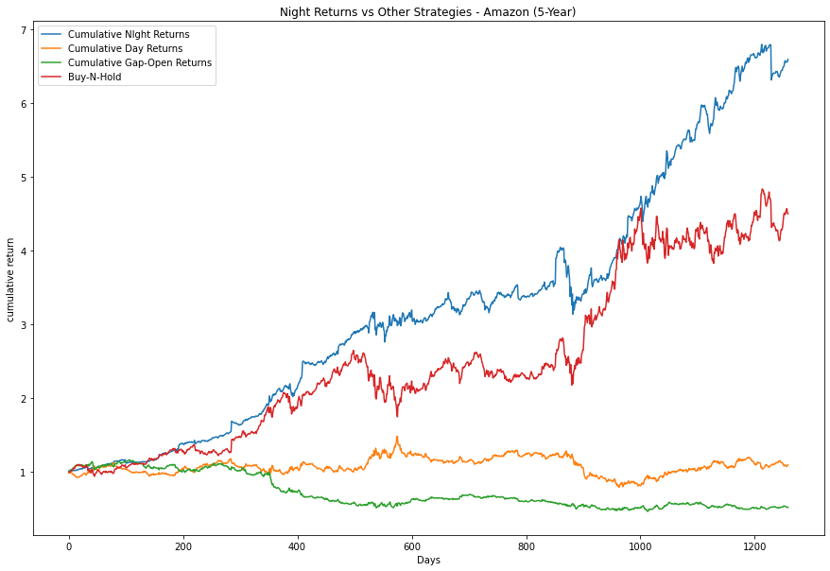

### **Comparison of all four strategies for Apple Inc5-year period**

The same when applied to Apple Inc shows a different behavior.

Cumulative % Night Returns in Apple: 101.18

Cumulative % Day Returns in Apple: -72.59

Cumulative Gap Open Returns in Apple: 32.17

Cumulative BuyNhold Returns in Apple: 465.13

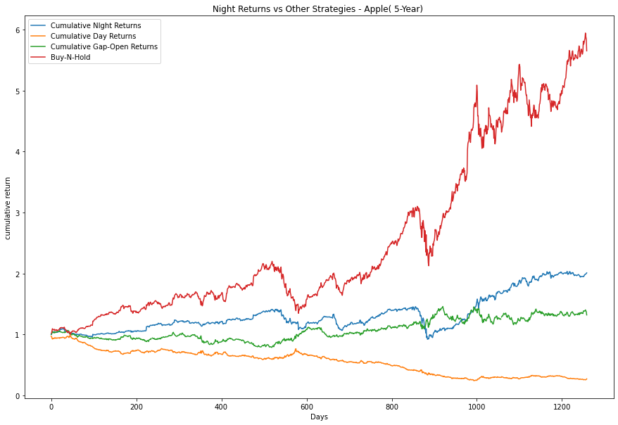

Apple Inc fared well in the Buy-N-Hold strategy and outperformed all other strategies. The % Night returns fared better than the % Day returns.

## **Performance Analysis**

### **% Nightly vs % Day for Amazon for Multiple Time periods**

|  |  |  |  |  |
| --- | --- | --- | --- | --- |
|  | % Night Returns | % Day Returns | % Buy-N-Hold | % Gap-Open |
| 1 Month | 2.54 | -1.71 | 5.37 | -0.845 |
| 3 Months | -0.92 | -5.10 | 3.65 | 0.71 |
| 6 Months | 8.56 | -4.63 | 11.41 | -2.88 |
| 12 Months | 44.38 | 27.15 | 11.32 | 1.62 |
| 5 Years | 559.68 | 8.91 | 349.66 | -49.28 |

### **% Nightly vs % Day for Apple for Multiple Time periods**

|  |  |  |  |  |
| --- | --- | --- | --- | --- |
|  | % Night Returns | % Day Returns | % Buy-N-Hold | % Gap-Open |
| 1 Month | 1.69 | -0.72 | 2.13 | -0.26 |
| 3 Months | -0.10 | -15.85 | -16.97 | -1.98 |
| 6 Months | 2.95 | -16.77 | 22.1 | -1.19 |
| 12 Months | 30.6 | -4.96 | 33 | 0.72 |
| 5 Years | 101.18 | -72.59 | 465.13 | 32.1 |

### **Number of Positive and Negative Return trades for Amazon for Multiple Time periods**

|  |  |  |  |  |
| --- | --- | --- | --- | --- |
|  | Positive Night Returns count | Negative night Returnscount | Positive Day Returnscount | Negative Day Returnscount |
| 1 Month | 14 | 7 | 11 | 11 |
| 3 Months | 39 | 23 | 35 | 29 |
| 6 Months | 81 | 44 | 65 | 63 |
| 12 Months | 159 | 88 | 130 | 121 |
| 5 Years | 774 | 475 | 634 | 624 |

### **Number of Positive and Negative Return trades for Apple for Multiple Time periods**

|  |  |  |  |  |
| --- | --- | --- | --- | --- |
|  | Positive Night Returns count | Negative night Returns count | Positive Day Returns count | Negative Day Returns count |
| 1 Month | 13 | 8 | 11 | 11 |
| 3 Months | 35 | 28 | 28 | 36 |
| 6 Months | 71 | 55 | 64 | 64 |
| 12 Months | 143 | 106 | 129 | 123 |
| 5 Years | 701 | 547 | 583 | 673 |

From the tables above it can be seen that in both Apple and Amazon the Night strategy give better returns than the Day strategy. For Apple the Buy-n-Hold strategy outperformed all other strategies while for Amazon, the Night strategy outperformed.

## **Pros and Cons**

Some of the pros of this strategy are:

* It is not affected by volatility during market hours.
* Momentum and liquidity during opening hours are high so no difficulty in taking trades.
* Capital is risked for short amounts of time.

Some of the cons of this strategy include:

* Difficult to Sell exactly @ market open
* Is highly affected by financial reports.
* Cannot be saved from changes in price due to news.

## **Other Trading Strategies**

There are many other trading strategies including the GAP-Open strategy we discussed above.

Mean-Reversion trading strategy and 5 -20 Moving Average crossover strategy.